**Write Testable Code with Moq**

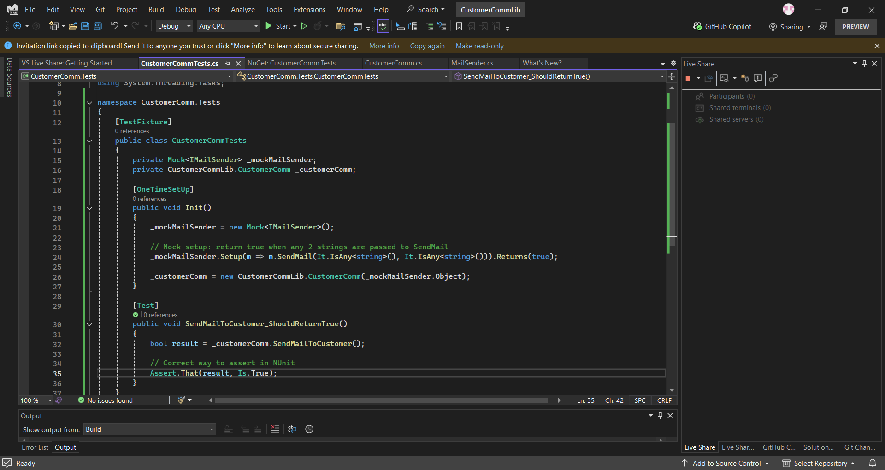

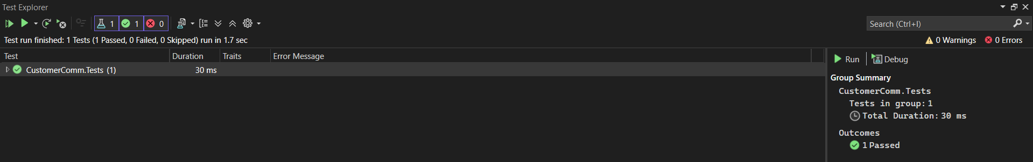OUTPUT :

